https://admin.joindeed.org/login

- Use your Walmart credentials to login if needed.
- Under the Home tab log volunteer hours
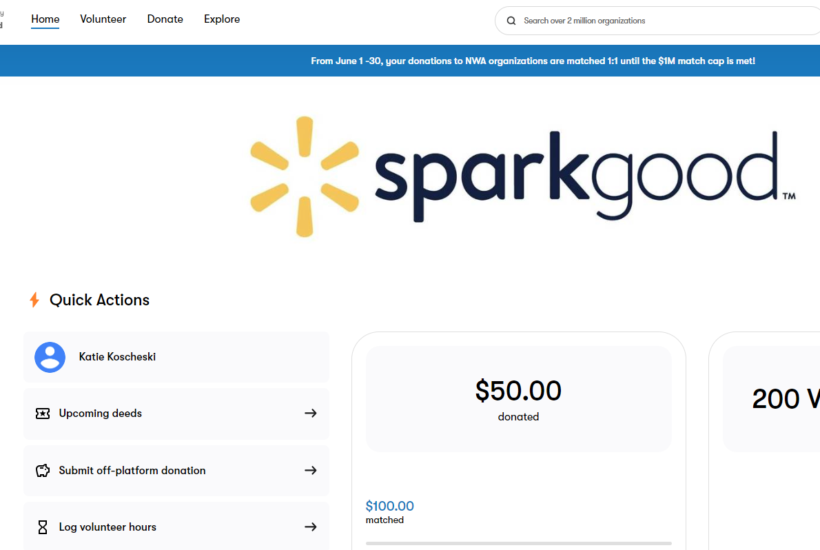
- Click on I volunteered outside of Deed.
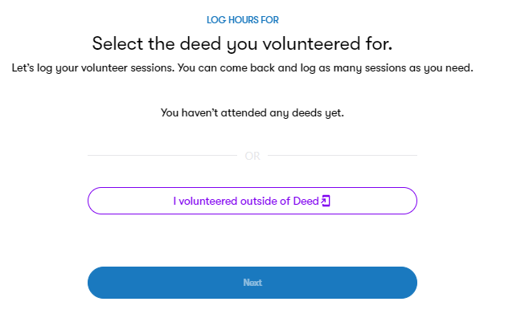
- Type in our EIN 84-4060268, click on Little League Baseball Inc.
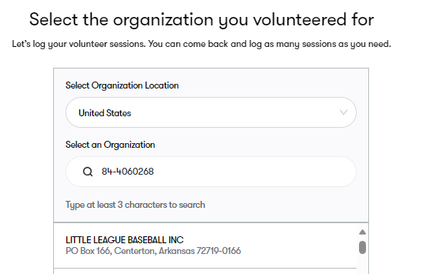
- Submit your hours volunteered by date. These must be inputted one at a time.
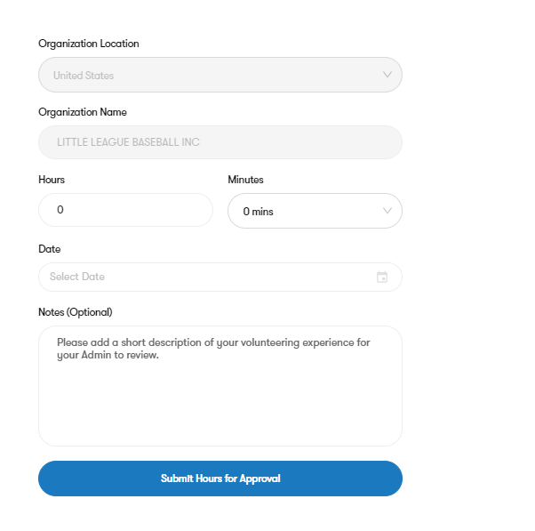
- Always choose to continue to qualify for matching grant.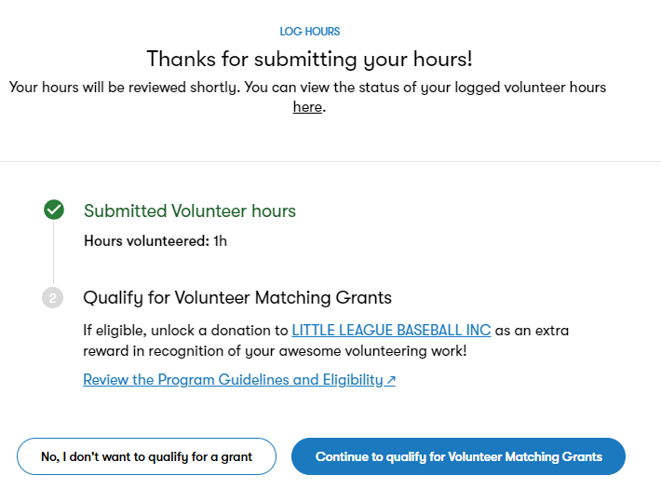
- Always answer in this order: Yes, No, Yes, No, No. Then submit.
